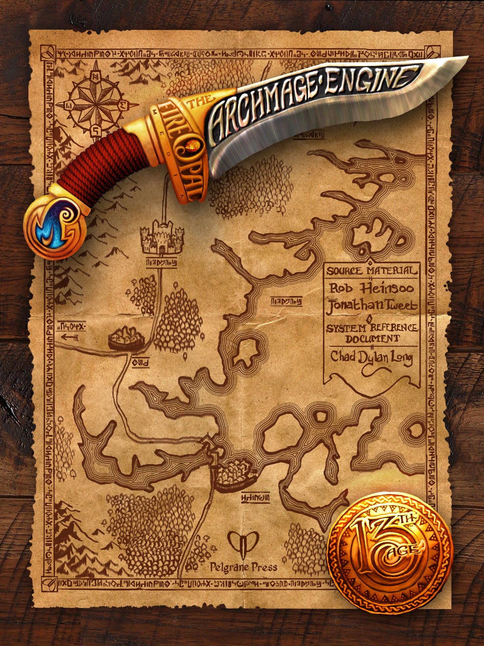

Multiclassing
A multiclass character belongs to two classes instead of one. Multiclassing provides versatility—two classes offer more options than one at the expense of raw power.
You can start at 1st level with a multiclass character or convert to being a multiclass character when you gain a level. Changing from a single-class character to a multiclass character during a campaign is often a consequence of some powerful story event.
The core multiclass rule is that you can’t apply a talent, feat, or class feature to a spell or attack from a different class. For example, a barbarian/rogue who is raging makes barbarian attacks, rolling 2d20s to hit, but can’t add rogue Sneak Attack damage on top of the barbarian melee attack. Likewise, a rogue that uses shadow walk has to make a rogue attack upon returning to play, not a barbarian rage attack. Another example: a sorcerer/wizard or sorcerer/cleric can’t gather power as a sorcerer and then get double damage casting a spell from their other class.
Some multiclass feats might break these general rules.
These prohibitions usually don’t apply to effects you create that don’t require actions to maintain. A cleric/barbarian could use an invocation at the start of the battle, cast a spell, and then start raging. The effects of the invocation would continue since it doesn’t require new actions to sustain it.
Rage, on the other hand, is a special case, preventing actions from other classes even though you don’t have to use actions to keep raging.

Multiclassing Basics
This is the guide to creating a multiclass character. If there’s an element of character class configuration not mentioned, assume that it works the same for multiclass characters as it does for single-class characters.
For character class specifics, see below. Note that many multiclasses offer bonus feats that help make up for some disadvantages when multiclassing.

Terminology
Your multiclass is a combination of your two classes separated by a slash. There’s no significance to the order. A fighter/wizard is the same as a wizard/fighter.
Technically, the rules presented here are for dual-classing, i.e. combining only two classes.

Level progression
You gain levels like any other character. For example, a 3rd level fighter/wizard is a 3rd level character, with 3rd level hit points and three feats (or four for a human). You add your level (3) to your attacks, to your defenses, and to your skill checks. You level up as fast as other characters and you never have to worry about gaining specific or separate class levels.
On the other hand, leveling up is not exactly like a single-class character. Multiclass characters have the class powers, attacks, maneuvers, bonus talents, and spells of a character that is one level lower than their actual level.
For example, as a 3rd level fighter/wizard, you’ll use the fighter and wizard level progression tables for 2nd level. In this example, as a fighter, you’ll know 4 maneuvers and they’ll all still have to be from the 1st level pool. As a wizard, you’ll know six 1st level spells. At 4th level, you then gain the maneuvers of a single-class 3rd level fighter and the spells of a single-class 3rd level wizard.

What you get as a 1st level multiclass character
Each multiclass option in the class-by-class list’s level progression sections tells you what you get as a 1st level character when your class abilities are a level lower.

Talents as a 1st level character
Choose one talent from each of your two class choices. Then choose your third talent from either of those classes.

Bonus talents as part of class progression
If your class gets bonus talents (barbarian, commander, fighter, monk, occultist, paladin, ranger), you still get them, but at one level later than a single-class character does.

Class features
Many classes contribute all of their class features to a multiclass. Others only allow some class features, or limit you from taking some talents or feats. The details are in the class-by-class multiclass list.

Ability score bonuses at character creation
You can select your ability score class bonus from the options available to either of your classes. For example, if you are a fighter/wizard, you can gain a single +2 class bonus to Strength, Constitution, Intelligence, or Wisdom.

Key ability scores & key modifiers
To be fully effective, multiclass characters have to be good in at least two ability scores, generally one for each class.
A multiclass character uses a special modifier for most of their attacks and other powers, called the key modifier. This modifier is the lower of two ability modifiers determined by your particular class combination. You use the key modifier whenever you would use either of those two ability scores for an attack or an effect of powers or spells.
You don’t necessarily use the key modifier for all attacks, only for attacks that would normally use one of the two ability scores in question. For example, a bard/cleric whose key modifier is Wis/Cha would use that modifier for all their spell attacks based on Wisdom or Charisma, but that character would still make cleric melee attacks with Strength, and bard melee attacks with Strength too.
You don’t use the key ability scores for skill checks. Skill checks live outside the class framework and use your normal ability scores, though if both scores are equal you will not notice the difference.
The Key Modifier table lists the modifier relevant to each multiclass combination. For example, a rogue/wizard’s primary abilities are Dexterity and Intelligence, so that character’s key modifier is the lower of the character’s Dexterity and Intelligence modifiers. You’ll use this key modifier in place of any Dexterity modifier or Intelligence modifier you use for all attacks, powers, spells, and class features or effects from the rogue or wizard class.
Core character stats like AC, PD, MD, and Initiative are not considered elements of your class, so they use the normal ability modifiers rather than the key modifiers.

Basic attacks
You have the basic attacks from both your classes. If your ability scores suggest that one of your basic attacks is better than the other, each time you make a basic attack you’ll have to specify which class you are using.

Hit Points
Your hit points are the average of the base HP of your two classes, + CON modifier, multiplied by 3, then rounded down.

Recovery dice
Average the dice from both classes, then round up to the next higher die size (d6, d8, d10, or d12). For example: d6 + d8 = d8; d6 + d10 = d8; d6 + d12 = d10; d8 + d10 = d10; d8 + d12 = d10; d10 + d12 = d12.

Armor and AC
Use the highest base AC provided by either of your classes for whichever type of armor you are wearing. However, you also retain the penalties for wearing shields or heavy armor while using attacks and spells from classes that have those penalties. For example, a 1st level wizard/fighter has a base AC of 16 in heavy armor from the fighter class. But while the character’s fighter attacks would be fine, any of the character’s wizard attacks (including spells) would take a –2 penalty.

PD & MD
Use the best PD and MD from either of your classes.

Weapon attacks
Use the better weapon attack abilities among your two classes.

Weapon damage penalty
Most multiclass characters must drop all of their weapon damage dice down one step. That means d12s become d10s; d10s become d8s; d8s become d6s; d6s become d4s; and d4s stay as d4s. This reduction does NOT apply if your multiclass contains only classes from the following list of skillful warriors: barbarian, bard, commander, fighter, paladin, ranger, or rogue.
If you’re one of the many multiclass characters affected by the weapon damage penalty, it applies only to your own attacks, not to the attacks of animal companions, summoned creatures, and the like.
The reduction also applies when you’ve found a way to gain a larger weapon damage die temporarily. For instance, a cleric casting the hammer of faith spell would get to use d12 damage dice for the rest of the battle, but a fighter/cleric (or any other cleric multiclass) would have to use d10 damage dice with the spell.

Feats
You can choose feats from either of your classes. You gain one feat per level like everyone else.

Gear
As a 1st level character, you’ve got all the gear you need from both your classes, as well as the normal starting gold pieces: 25 gp or 10 x d6 gp.

Key Ability Modifier
The important things to remember in keeping track of the key ability for a multiclass character are a) the key modifier table itself is not affected by any ability score swaps pulled off within class talents, and b) the talents are class elements that are affected by the key ability modifiers.
 | Barbarian | Bard | Chaos mage | Cleric | Commander
Barbarian | X | Str/Cha | Str/Cha | Str/Wis | Str/Cha
Bard | Str/Cha | X | Str OR Dex/Cha | Wis/Cha | Str/Cha
Chaos mage | Str/Cha | Str OR Dex/Cha | X | Wis/Cha | Str/Cha
Cleric | Str/Wis | Wis/Cha | Wis/Cha | X | Wis/Cha
Commander | Str/Cha | Str/Cha | Str/Cha | Wis/Cha | X
Druid | Str/Wis | Wis/Cha | Wis/Cha | Str/Wis | Wis/Cha
Fighter | Str/Con | Str/Cha | Str/Cha | Str/Wis | Str/Cha
Monk | Str/Dex | Dex/Cha | Dex/Cha | Dex/Wis` | Str/Dex
Necromancer | Str/Int | Int/Cha | Int/Cha | Int/Cha | Int/Cha
Occultist | Str/Int | Int/Cha | Int/Cha | Int/Wis | Int/Cha
Paladin | Str/Cha | Str/Cha | Str/Cha | Str/Wis | Str/Cha
Ranger | Str/Dex | Str OR Dex/Cha | Str OR Dex/Cha | Str/Wis | Str/Cha
Rogue | Str/Dex | Dex/Cha | Dex/Cha | Dex/Wis | Dex/Cha
Sorcerer | Str/Cha | Dex/Cha | Con/Cha | Wis/Cha | Str/Cha
Wizard | Str/Int | Int/Cha | Int/Cha | Int//Wis | Int/Cha

 | Druid | Fighter | Monk | Necromancer | Occultist
Barbarian | Str/Wis | Str/Con | Str/Dex | Str/Int | Str/Int
Bard | Wis/Cha | Str/Cha | Dex/Cha | Int/Cha | Int/Cha
Chaos mage | Wis/Cha | Str/Cha | Dex/Cha | Int/Cha | Int/Cha
Cleric | Str/Wis | Str/Wis | Dex/Wis | Int/Wis | Int/Wis
Commander | Wis/Cha | Str/Cha | Str/Dex | Int/Cha | Int/Cha
Druid | X | Str/Wis | Dex/Wis | Int/Wis | Int/Wis
Fighter | Str/Wis | X | Str/Dex | Str/Int | Str/Int
Monk | Dex/Wis | Str/Dex | X | Dex/Int | Dex/Int
Necromancer | Int/Wis | Str/Int | Dex/Int | X | Int/Cha
Occultist | Int/Wis | Str/Int | Dex/Int | Int/Cha | X
Paladin | Str/Wis | Str/Cha | Str/Dex | Str/Int | Str/Int
Ranger | Str OR Dex/Wis | Str/Dex | Str/Dex | Str OR Dex/Int | Str OR Dex/Int
Rogue | Dex/Wis | Str/Dex | Str/Dex | Dex/Int | Dex/Int
Sorcerer | Wis/Cha | Dex/Cha | Dex/Cha | Int/Cha | Int/Cha
Wizard | Int/Wis | Dex/Int | Dex/Int | Int/Cha | Int/Wis

 | Paladin | Ranger | Rogue | Sorcerer | Wizard
Barbarian | Str/Cha | Str/Dex | Str/Dex | Str/Cha | Str/Int
Bard | Str/Cha | Str OR Dex/Cha | Dex/Cha | Str OR Dex/Cha | Int/Cha
Chaos mage | Str/Cha | Str OR Dex/Cha | Dex/Cha | Con/Cha | Int/Cha
Cleric | Str/Wis | Str/Wis | Dex/Wis | Wis/Cha | Int/Wis
Commander | Str/Cha | Str/Cha | Dex/Cha | Str/Cha | Int/Cha
Druid | Str/Wis | Str OR Dex/Wis | Dex/Wis | Wis/Cha | Int/Wis
Fighter | Str/Cha | Str/Dex | Str/Dex | Str/Cha | Str/Int
Monk | Str/Dex | Str/Dex | Str/Dex | Dex/Cha | Dex/Int
Necromancer | Str/Int | Str OR Dex/Int | Dex/Int | Int/Cha | Int/Cha
Occultist | Str/Int | Str OR Dex/Int | Dex/Int | Int/Cha | Int/Wis
Paladin | X | Str/Dex | Str/Dex | Str/Cha | Str/Int
Ranger | Str/Dex | X | Str/Dex | Dex/Cha | Dex/Int
Rogue | Str/Dex | Str/Dex | X | Dex/Cha | Dex/Int
Sorcerer | Str/Cha | Dex/Cha | Dex/Cha | X | Int/Cha
Wizard | Str/Int | Dex/Int | Dex/Int | Int/Cha | X
Note: Multiclasses that include only the barbarian, bard, commander, fighter, paladin, ranger, and rogue classes don’t take the weapon damage die penalty suffered by other multiclass characters. The multiclass ability scores of these combinations appear in italics above.

Barbarian Multiclass
You get to start with three talents, but you don’t get bonus talents until 6th level and 9th level.
While raging, you cannot use attacks, powers, or spells from another class unless you take Controlled Rage.

Controlled Rage

Adventurer Tier
You can use powers and attacks from your other class while raging. You can’t use the extra d20 that Barbarian Rage gives you while making an attack from the other class, but at least you can slip out of your rage long enough to use a power or attack from your other class.

Champion Tier
Once per battle while raging, you can use a melee attack from your other class as if it was a barbarian attack, rolling 2d20 for the attack. (Examples of possible uses include a bard’s flexible attack battle cries, a commander attack using the Lead from the Front talent that will garner command points, a fighter’s flexible attacks, a ranger’s double melee attack, and so on.)

Bard Multiclass
You lag one level behind in the battle cries and spells/songs known columns of the Bard Level Progression table.
As a 1st level bard, you start with only one 1st level battle cry and one 1st level spell or song.
As usual, the Battle Skald or Spellsinger talents could still add a battle cry or spell/song to what you’re getting as a multiclass bard.
Note that the Jack of Spells advantages would only apply to spells jacked by the talent, not to spells known through the multiclass.
If you multiclass with another class that has flexible attacks, such as the fighter or a druid that takes that talent, consider the two feats that follow. Without the feats, you must always declare whether you are using a bard flexible attack or a flexible attack from your other class.

True Flexibility

Adventurer Tier
Once per battle, as long as both classes use flexible attacks for the type of attack you are making, you can choose to roll a flexible attack without deciding which of your two classes it is linked to. Choose from all your flexible attacks after you see the result of the roll.

Champion Tier
You can now use the adventurer-tier feat twice per battle.

Chaos Mage Multiclass
You lag one level behind in the three central columns of the Chaos Mage Level Progression table: daily spells, once-per-battle spells, and spell level.
Drop three new stones of the same color (but a different color from your attack/defense/iconic stones) into your chaos mage bag. These stones correspond to your other class. When you draw one of the stones, any warp effects or high weirdness you’ve got going on from a previous chaos mage turn end. On your next turn, you must use a standard action attack from your non-chaos mage class, just as if you had drawn a stone for one of your standard three types of chaos magic.
If your chaos mage talents allow you to draft random spells from other classes (Stench of Necromancy, Touch of Wizardry, Trace of the Divine, and Whiff of Sorcery), those spells remain with the attack or defense slots you assigned them to as usual.

Continual Warp

Adventurer Tier
If you have a warp effect already going, drawing the stone from your other class doesn’t cancel the warp effect. The warp effect continues until it’s replaced by another warp effect or the end of the battle, as usual.

Champion Tier
If you invested in high weirdness, your high weirdness effects don’t stop when you draw a multiclass stone.

Cleric Multiclass
You lag one level behind in the spells known columns of the Cleric Level Progression table.
As a 1st level multiclass cleric, you start with three 1st level spells.

Commander Multiclass
You lag one level behind in the class-specific elements of the Commander Level Progression table—so it only affects the number of commands and tactics you have and the pool you can draw them from.

Many Fronts

Adventurer Tier
Once per battle, use a melee attack from your non-commander class in place of a commander attack when you use your Front Line Fighting feature.

Champion Tier
You can now use the adventurer-tier feat twice per battle.

Druid Multiclass
You lag one level behind in the powers and spells known columns of the Druid Level Progression tables.

Fighter Multiclass
You lag one level behind two columns of the Fighter Level Progression Table: Maneuvers Known and Maneuver Pool Available. You also won’t get the fighter’s normal bonus talent at 6th level, instead receiving it at 7th level.
As a 1st level multiclass fighter, you start knowing two maneuvers from the 1st level pool.

Armored Warfare

Adventurer Tier
Once per battle while wearing heavy armor, use an attack from a class that normally takes an attack penalty while wearing heavy armor without taking that penalty.

Champion Tier
You can now ignore heavy armor attack penalties while the escalation die is 3+.

Monk Multiclass
A multiclass monk does get a +2 class bonus to three abilities, but does not get to use Focus abilities as the other class.
You lag one level behind in the three columns of the Monk Level Progression table: class talents, forms, and ki.
The multiclass monk’s JAB, PUNCH, and KICK attacks damage dice decrease one size just like the WEAPON attacks of all classes. Yes, this means your JAB dice are d4s, PUNCH dice are d6s, and KICK dice are d8s.

Necromancer Multiclass
You lag one level behind in the spells known columns of the Necromancer Level Progression table.

Occultist Multiclass
You gain the focus required to use a serious occultist spell by using your standard action during your turn to set that up. But when you have your occultist focus, you don’t get to use actions and powers and spells from other classes.
You lag one level behind in the spells known columns of the Occultist Level Progression table. You also won’t get the occultist’s normal bonus talents at 5th level and 8th level, instead receiving them at 6th level and 9th level.

Wider Focus

Adventurer Tier
Once per battle, you can use a power, spell, or other effect from a different class while maintaining your occultist focus.

Paladin Multiclass
You don’t get the paladin’s normal bonus talents at 5th and 8th level, instead receiving them at 6th level and 9th level.

Armored in Life

Adventurer Tier
Once per battle while wearing heavy armor, use an attack from a class that normally takes an attack penalty while wearing heavy armor without taking that penalty.

Champion Tier
Two battles per day, avoid all attack penalties for wearing heavy armor from a class that normally has such an attack penalty. During any other battles that day, you can still only use the once-per battle power from the adventurer-tier feat.

Ranger Multiclass
Like the paladin, your Level Progression table doesn’t have many class-specific elements. You won’t get the ranger’s normal bonus talents at 5th and 8th level, instead receiving them at 6th level and 9th level.
Unless you’ve multiclassed with one of the other skilled weapon-using classes, your damage dice for the Double Melee Attack and Double Ranged Attack talents drop down another size (usually from d6s to d4s) as a multiclass ranger.

Two-weapon Multiclass

Adventurer Tier
While you are fighting with two melee weapons, you now gain the benefit of your Two-Weapon Mastery talent and any feats you’ve taken for it even when using attacks from your non-ranger class.

Adventurer Tier
You can use your Archery ranger talent and any feats you’ve taken for it even when using ranged attacks from your non-ranger class.

Rogue Multiclass
You lag one level behind in the Powers Known and Pool Available columns of the Rogue Level Progression table. At 1st level, you know 3 powers, all of them from the 1st level pool.
Combining your Sneak Attack damage with attacks from other classes remains off-limits.

Seize the Momentum

Adventurer Tier
Once per day when you hit with an attack from your non-rogue class, you can gain momentum as if you had used a rogue attack.

Champion Tier
In addition to using the adventurer-tier feat once per day, you can also use it once per battle (so in a four-battle day, you could use it five times).

Sorcerer Multiclass
You lag one level behind in the spells known columns of the Sorcerer Level Progression table. At 1st level, you know three 1st level spells.

Diverse Gathering

Adventurer Tier
Once per day, you can cast a non-sorcerer spell after you have gathered power. You double the damage of the spell as if it were a sorcerer spell.

Champion Tier
You can now also gather power for a non-sorcerer spell as per the adventurer-tier feat once per battle while the escalation die is 4+ (so in a four battle day, you could use it up to five times assuming the escalation die allows it).

Wizard Multiclass
You lag one level behind in the spells known columns of the Wizard Level Progression table.
At 1st level, you know four 1st level spells

