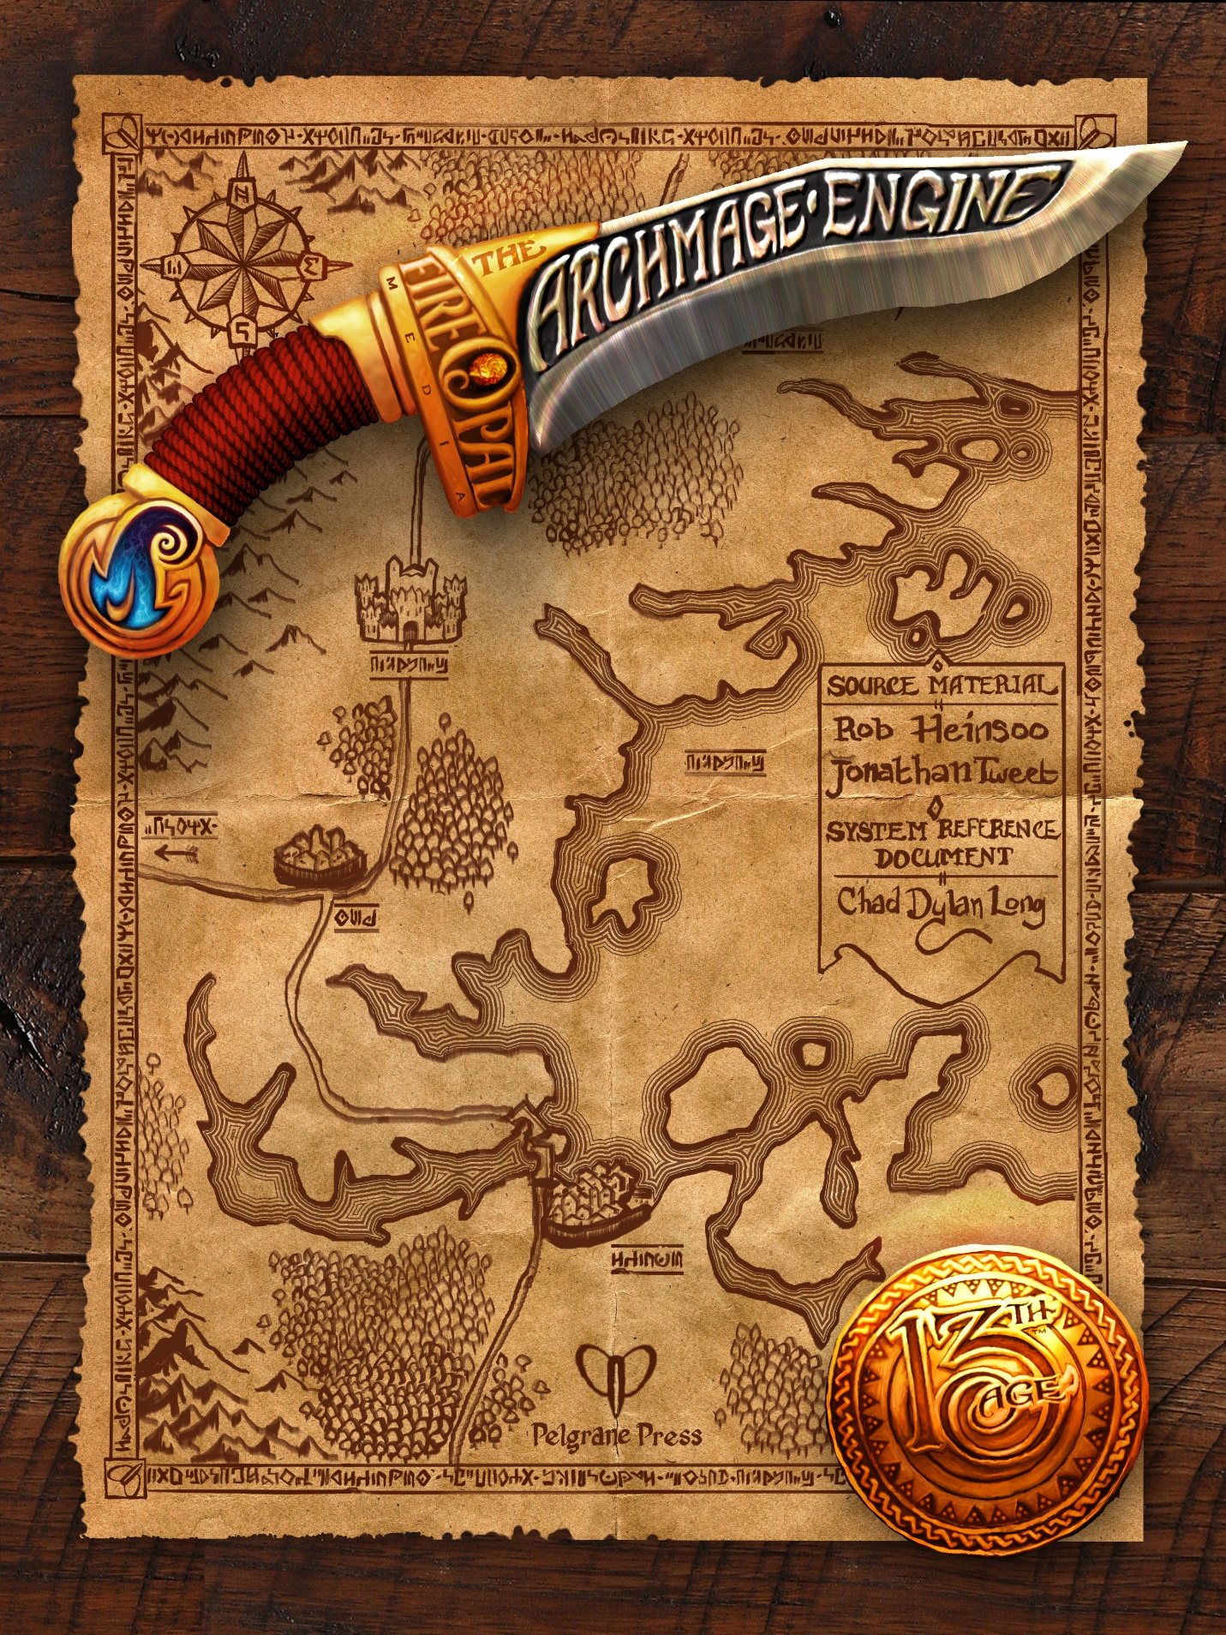

Races
The major races included in the 13th Age Archmage Engine include humans, dwarves, elves, gnomes, half-elves, half-orcs, and halflings. Your character need not be limited to these races, however. Minor races, including Dragonic/Dragonspawn, Holy One/Aasimar, Forgeborn/Dwarf-forged, and Tiefling/Demontouched, are also referenced below.
Each race is associated with two ability scores, one of which can be chosen for your character’s racial bonus.
Race | Str | Con | Dex | Int | Wis | Cha | Any
Human |  |  |  |  |  |  | +2
Dwarf |  | +2 |  |  | +2
Dark elf |  |  | +2 |  |  | +2
High elf |  |  |  | +2 |  | +2
Wood elf |  |  | +2 |  | +2
Gnome |  |  | +2 | +2
Half-elf |  | +2 |  |  |  | +2
Half-orc | +2 |  | +2
Halfling |  | +2 | +2
Dragonic/Dragonspawn | +2 |  |  |  |  | +2
Holy One/Aasimar |  |  |  |  | +2 | +2
Forgeborn/Dwarf-forged | +2 | +2
Tiefling/Demontouched | +2 |  |  | +2
The character also receives a separate class bonus. These two bonuses must apply to different ability scores.
Each race also provides the character a special power that can be used once per battle. (It is regained after a quick rest.) This is called the racial power.

Human

Racial Bonus
+2 to any ability score.

Bonus Feat
At 1st level, human PCs start with two feats instead of one.

Racial Power

Quick to Fight
At the start of each battle, roll initiative twice and choose the result you want.

Champion Feat
If you roll a natural 19 or 20 for initiative, increase the escalation die by 1 (usually from 0 to 1 since it’s the start of the battle).

Dwarf

Racial Bonus
+2 Con or +2 Wis

Racial Power

That’s Your Best Shot?
Once per battle as a free action after you have been hit by an enemy attack, you can heal using a recovery. If the escalation die is less than 2, you only get half the usual healing from the recovery. Unlike other recoveries that might allow you to take an average result, you have to roll this one!
Note that you can’t use this ability if the attack drops you to 0 hp or below. You’ve got to be on your feet to sneer at their attack and recover.

Champion Feat
If the escalation die is 2+ when you use that’s your best shot, the recovery is free.

Dark Elf

Racial Bonus
+2 Dex or +2 Cha

Adventurer Feat (Elf)

Heritage of the Sword
If you can already use swords that deal d6 and d8 damage without attack penalties, you gain a +2 damage bonus with them. (This bonus doesn’t increase miss damage.)
Otherwise, if your class would ordinarily have an attack penalty with such swords, you can now use them without penalties.

Racial Power

Cruel
Once per battle, deal ongoing damage to a target you hit with a natural even attack roll as a free action. The ongoing damage equals 5 times your level. (For example, at 3rd level you would deal 15 ongoing damage against a single target.) As usual, a normal save (11+) ends the damage. A critical hit doesn’t double this ongoing damage.

Champion Feat
Once per day, you can instead use cruel to deal 5 ongoing damage per level against an enemy you miss or that you roll a natural odd attack against.

High Elf

Racial Bonus
+2 Int or +2 Cha

Racial Power

Highblood Teleport
Once per battle as a move action, place yourself in a nearby location you can see.

Champion Feat
Deal damage equal to twice your level to one enemy engaged with you before or after you teleport.

Wood Elf

Racial Bonus
+2 Dex or +2 Wis

Racial Power

Elven Grace
At the start of each of your turns, roll a die to see if you get an extra standard action. If your roll is equal to or lower than the escalation die, you get an extra standard action that turn.
At the start of battle, you roll a d6. Each time you successfully gain an extra action, the size of the die you roll increases by one step on the following progression: (d4), d6, d8, d10, d12, d20. If you get an extra action after rolling a d20, you can’t get any more extra actions that battle.

Champion Feat
Once per day, start a battle rolling a d4 for elven grace instead of a d6.

Gnome

Racial Bonus
+2 Dex or +2 Int

Small
Gnomes have a +2 AC bonus against opportunity attacks.

Racial Power

Confounding (Racial Power)
Once per battle, when you roll a natural 16+ with an attack, you can also daze the target until the end of your next turn.

Champion Feat
Instead of being dazed, the target of your confounding ability is weakened until the end of your next turn.

Minor Illusions
As a standard action, at-will, you can create a strong smell or a sound nearby. Nearby creatures that fail a normal save notice the smell or sound. Creatures that make the save may notice it but recognize it as not exactly real.

Half-elf

Racial Bonus
+2 Con or +2 Cha

Racial Power

Surprising
Once per battle, subtract one from the natural result of one of your own d20 rolls.

Champion Feat
You gain an additional use of surprising each battle, but you can only use it to affect a nearby ally’s d20 roll.

Halfling

Racial Bonus
+2 Con or +2 Dex

Small
Halflings have a +2 AC bonus against opportunity attacks.

Racial Power

Evasive
Once per battle, force an enemy that hits you with an attack to reroll the attack with a –2 penalty.

Champion Feat
The enemy’s reroll takes a –5 penalty instead.

Half-orc

Racial Bonus
+2 Str or +2 Dex

Racial Power

Lethal
Once per battle, reroll a melee attack and use the roll you prefer as the result.

Champion Feat
If the lethal attack reroll is a natural 16+, you can use lethal again later this battle.

Dragonic/Dragonspawn

Racial Bonus
+2 Str or +2 Cha

Racial Power

Breath Weapon
Once per battle, make a close-quarters breath weapon attack as a quick action using your highest ability score against one nearby enemy’s Physical Defense. On a hit, the attack deals 1d6 damage per your level of an energy type that makes sense for your character.

Champion Feat
Your breath weapon attack targets 1d3 nearby enemies in a group instead.

Holy One/Aasimar

Racial Bonus
+2 Wis or +2 Cha

Racial Power

Halo
Once per battle as a free action during your turn, gain a +2 bonus to all defenses until you are hit by an attack (or until the battle ends).

Champion Feat
Halo also activates automatically any time you heal using a recovery.

Forgeborn/Dwarf-forged

Racial Bonus
+2 Str or +2 Con

Racial Power

Never Say Die
Whenever you drop to 0 hp or below, roll a normal save if you have a recovery available. On an 11+, instead of falling unconscious, you stay on your feet and can heal using a recovery. Add the recovery hit points to 0 hp to determine your hp total.

Champion Feat
If you roll a 16+ on your never-say-die save, you gain an additional standard action during your next turn.

Tiefling/Demontouched

Racial Bonus
+2 Str or +2 Int

Racial Power

Curse of Chaos
Once per battle as a free action when a nearby enemy rolls a natural 1–5 on an attack or a save, turn their roll into a natural 1 and improvise a further curse that shows how their attempt backfires horribly.
A curse should have about the same impact as a typical once-per-battle ability. For example, a typical curse might lead to the cursed attacker dealing half damage to themself with their fumbled attack and being dazed until the end of their next turn. The GM may reward storytelling flair and/or limit the suggested effects of the curse.

Champion Feat
Whenever a nearby enemy rolls a natural 1 on an attack against you, you can use curse of chaos against them without expending it.

